# What is Persistent Chat (pChat)?

Persistent Chat (pChat) is a realtime chat room service within Skype. Group Instant Messages can be difficult to manage throughout the day. Some participants may not be looking at their screen when they get the request to join a group IM, and a lot of times, discussions occurring within a group chat before everyone has accepted can go unread by some individuals. pChat remedies this gap.

pChat keeps 30 days of conversation history in the chat room. Teams can have conversations with others directly, while keeping their team informed. Using the popular social media “@mention” feature, you can mention someone by name and they will receive a special notification which will prompt them to enter the chat room.

Note: Ctrl+Click to Jump to a specific step

Step 1 – How to Create and Manage your own Chat Rooms

Step 2 – Find and Follow Rooms

Step 3 – Quickly set your Notifications and Ego Feed (@mention feature)

# Step 1 – How to Create and Manage your own Chat Rooms

1. 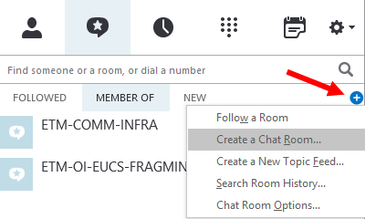To create a new room (or manage rooms you’ve created), you’ll click on the plus sign and select “Create a Chat Room”.
2. 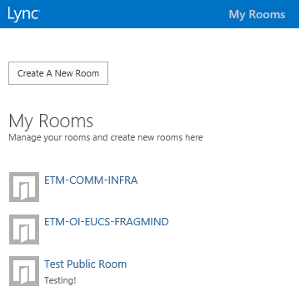From here, an Internet Explorer window will open. Log in with your LANID and password, and then you’ll see a button to create a room and a list of rooms you’ve created (or rooms you are a manager of).
3. Click the “Create A New Room” button, and follow the instructions in the screenshot below.

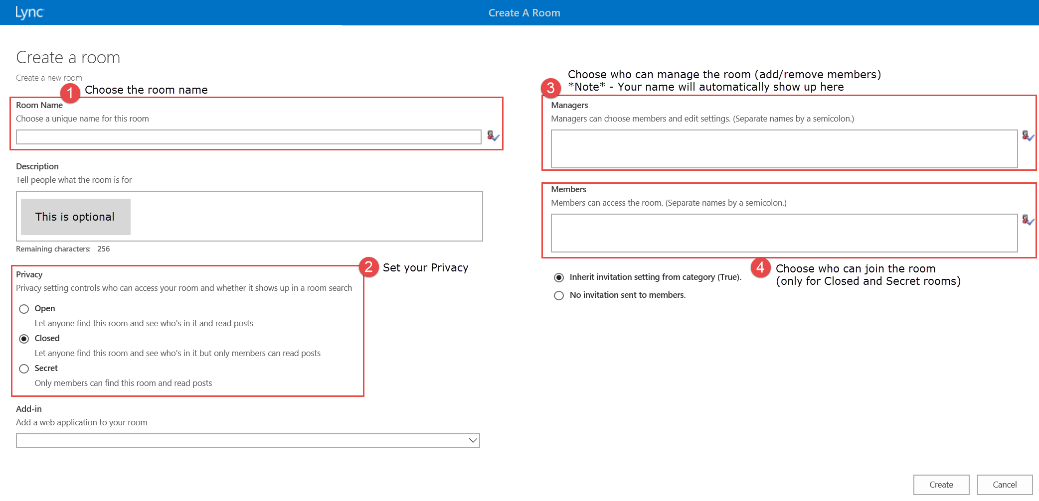

# Step 2 – Find and Follow Rooms

1. 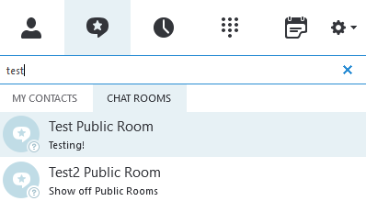For Open (Public) rooms, search the room name. You can join the room by double-clicking on the search result.
2. 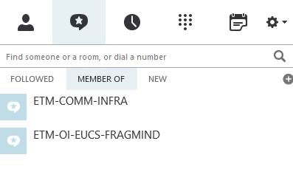For Closed and Private rooms of which you are a member, select the **Member Of** tab for a list of those rooms. You can join the room by double-clicking on it.

1. 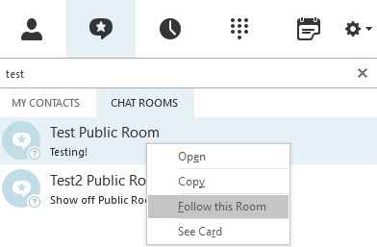In order to receive notifications for a room, you must follow that room. You can right-click on the room name and select “Follow this Room”. Do this for searched rooms or rooms in your **Member Of** tab.
2. 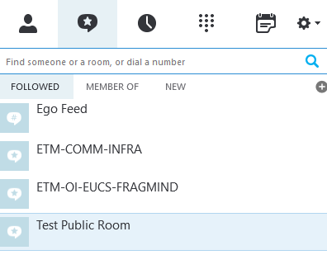A list of your followed rooms will show up in your **Followed** tab. Once it appears here, you will receive notifications of messages sent to these rooms.

# Step 3 – Quickly set your Notifications and Ego Feed

Below is the recommended settings to start with. You can customize your settings per room, which is explained in another document (Customize pChat Notification Settings).

## Set up Default Notification settings for pChat

1. Go to the Skype Gear, then choose “Persistent Chat” on the left side
2. Set the notification settings as outlined in the screenshot below

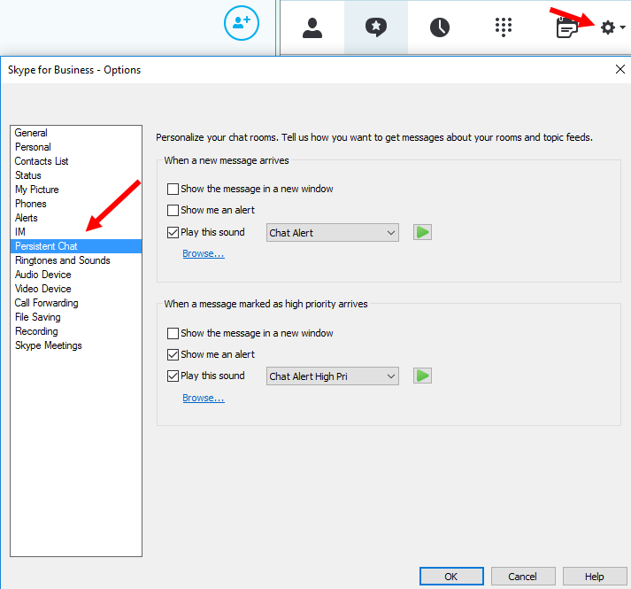

## What do these notification settings mean?

**Show the message in a new window** – This will pop your chat room in a separate window when a message is posted in a chat room.

**Show me an alert** – This will create a desktop “toast pop” for a message posted in a chat room.

**Play this sound** – This will play a sound for every message posted in the chat room.

## Configure your Ego Feed (@mention feature)

1. By Default, you should see your Ego feed under your “Followed” Tab. This is how Skype will notify you if someone writes your first name, last name or LAN ID in a chat room.
2. Right-click on the Ego Feed, go to “Change Notification Settings” and choose “Customize settings”, use the recommended settings below.

